Puzzle 1  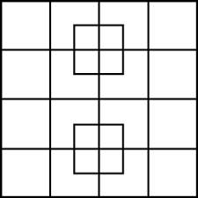 | Puzzle 2  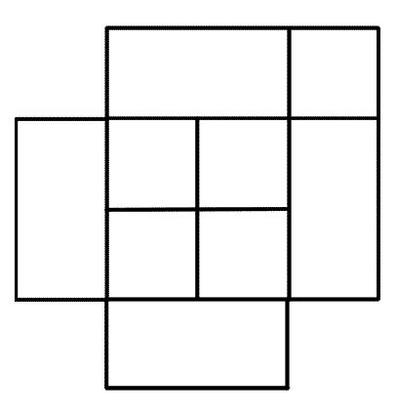
Puzzle 3  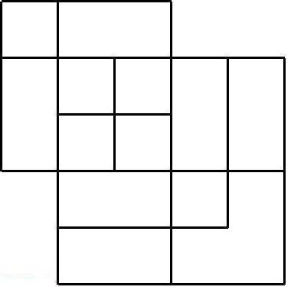 | Puzzle 4  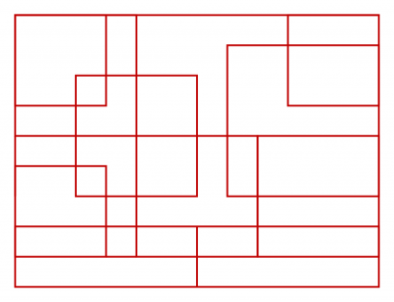
Puzzle 5  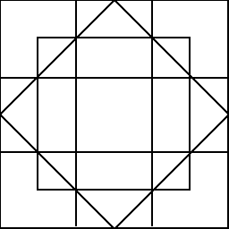 | Puzzle 6  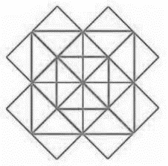

Puzzle 1 ____
Puzzle 2 ____
Puzzle 3 ____
Puzzle 4 ____
Puzzle 5____
Puzzle 6_____

