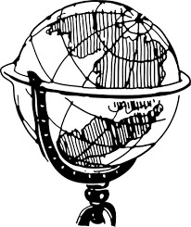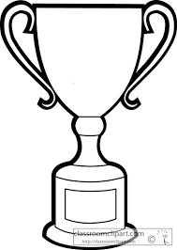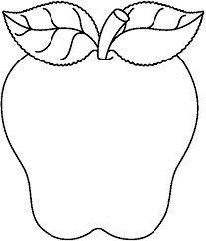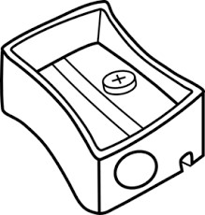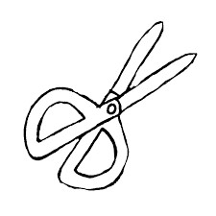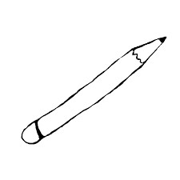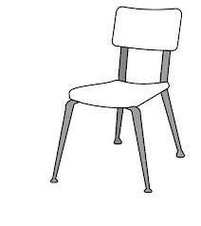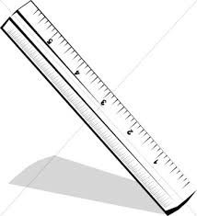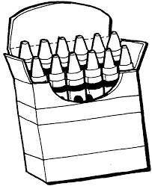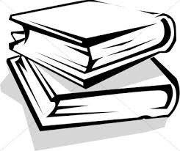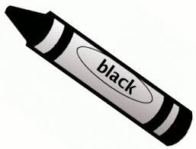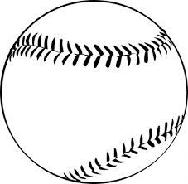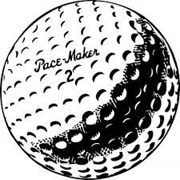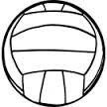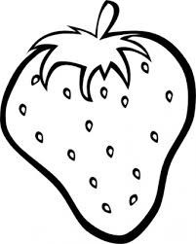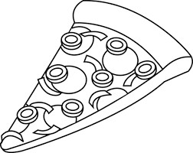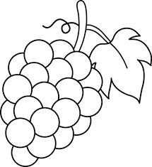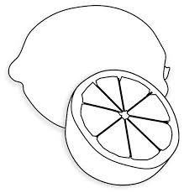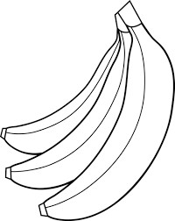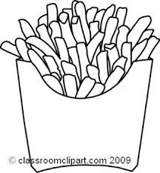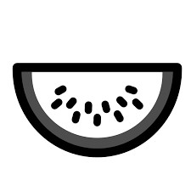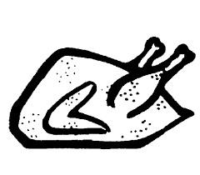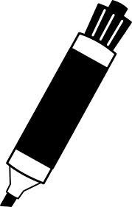

1) Which of the following pieces of furniture was shown:

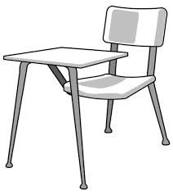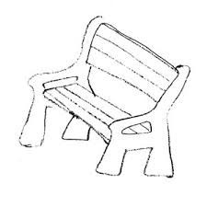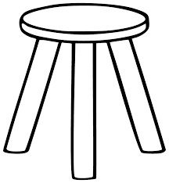

2) What colour was on the crayon labelled?

1. Red
2. Black
3. Purple
4. Orange

3) How many different kinds of fruit were included?

a) 2  
b) 3  
c) 5  
d) 6

4) Which writing utensil was not included?

1. pencil
2. crayons
3. pen
4. marker

5) Which ball was not included?

a) b) c) d)

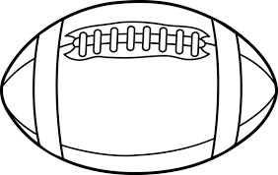

6) Which award was shown:

1. diploma
2. trophy
3. medal
4. ribbon

7) What is in the top left corner?

1. a strawberry
2. a globe
3. a chair
4. a sharpener

8) How many kinds of food are shown?

1. 4
2. 5
3. 8

d) 9

9) What kind of cutting device was shown?

1. a knife
2. scissors
3. a sword
4. a saw

10) How many things could be used to write with?

1. 4
2. 5
3. 3
4. 6

11) Which fruits were in the picture?

1. Apple, banana, orange
2. Grapes, lemon, strawberry
3. Grapes, orange, apple
4. Banana, strawberry, orange

12) How many books were in the picture?

1. 1
2. 2
3. 3
4. 4